2025/02/20 V1.0

|  |
| --- |
|  |

|  |
| --- |
| **Raffar Technology Corp.** |
| **RT7216NQ GUI**  **User guide** |
| www.raffar.com.tw |

**RT7216NQ controller configuration**

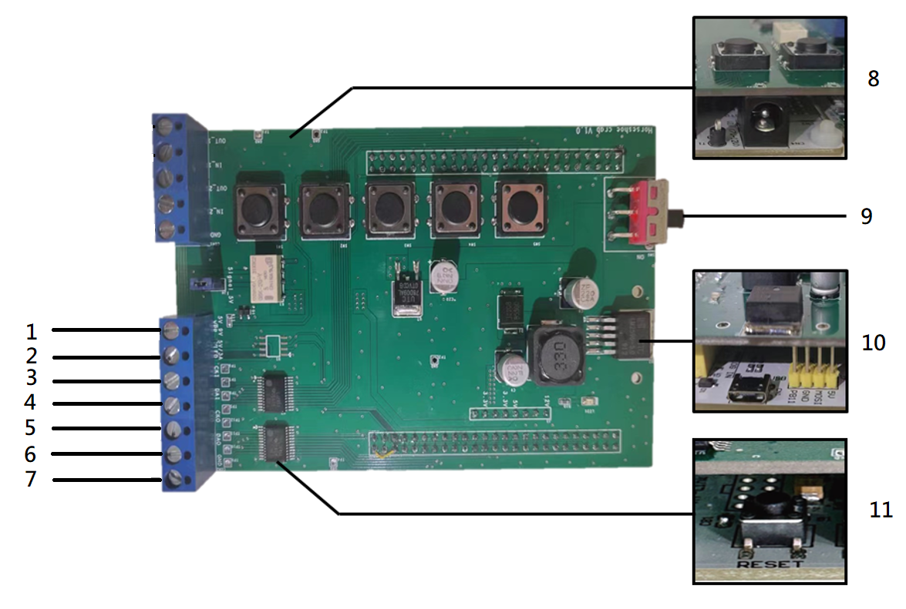

Fig. 1 Controller configuration

|  |  |  |
| --- | --- | --- |
| Item | Name | Description |
| 1 | VPP | Connect to RT7216NQ VPP pin. Idle at 5V.  Reaches 9V when OTP program memory command is issued. |
| 2 | VLED | Connect to RT7216NQ VDD pin. Idle at 5V |
| 3 | CKI | Connect to RT7216NQ CKI pin. Idle at 5V |
| 4 | DAI | Connect to RT7216NQ DAI pin. Idle at 5V |
| 5 | CKO | Connect to RT7216NQ CKO pin. Idle at 5V |
| 6 | DAO | Connect to RT7216NQ DAO pin. Idle at 5V |
| 7 | GND | Connect to RT7216NQ GND pin. |
| 8 | Power supply socket | Connect with 12V DC |
| 9 | Power switch | LED on controller turns on when active, turn off to power off all connections to RT7216NQ IC |
| 10 | Micro USB socket | Connect to PC |
| 11 | RESET button | Manual reset button |

Table. 1 Controller configuration

**GUI Connecting to Controller**

1. Run RT7216NQ GUI.exe. Fig.2 Startup GUI window should be displayed.

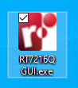

Fig. 2 RT7216NQ GUI.exe

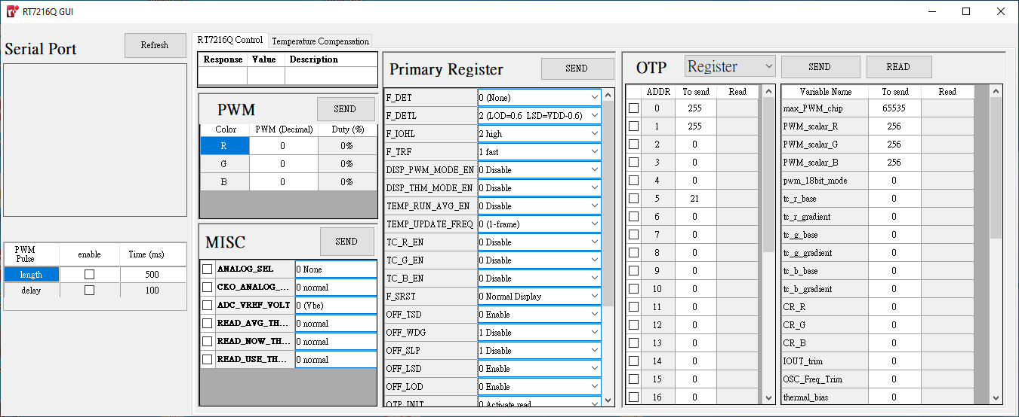

Fig. 3 Startup GUI window

1. Connect RT7216NQ driver IC to RT7216NQ controller. Refer to the datasheet for RT7216NQ driver IC PINOUT. Refer to Fig.1 and Table. 1 for controller configuration (item 1 to 7).
2. Press “Refresh” button to list all USB connections. 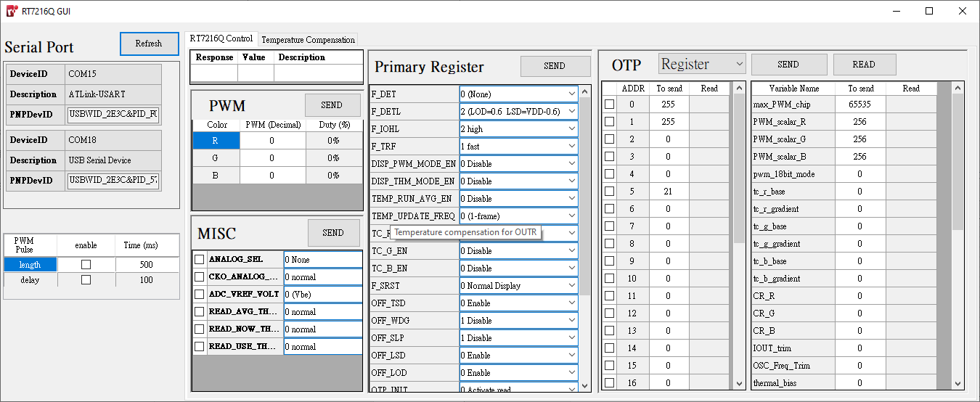

Fig. 4 Refresh button

1. Left-click on one of the listed serial port, RT7216NQ controller should have the description “USB Serial Device”. RT7216NQ GUI will open a serial port connection with the selected device.

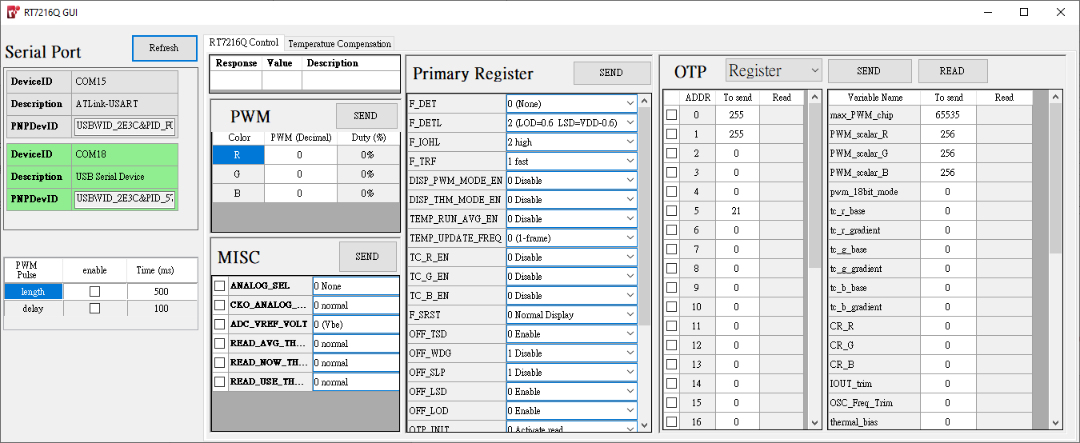

Figure. 5 Select Serial Port

1. When Multiple USB devices are connected, it is possible to connect to the wrong serial Port.   
   Try a different USB Serial device if the controller does not respond.

**Communication Architecture**



Figure. 6 Communication Architecture of RT7216NQ GUI

For every GUI command, the controller will issue a 56bit command to IC. Depending on the 56bit command, IC may or may not send data report to MCU. Refer to Programming Guide on command types with data report. If RT7216NQ IC reports data, it will be included in the response from controller to PC.

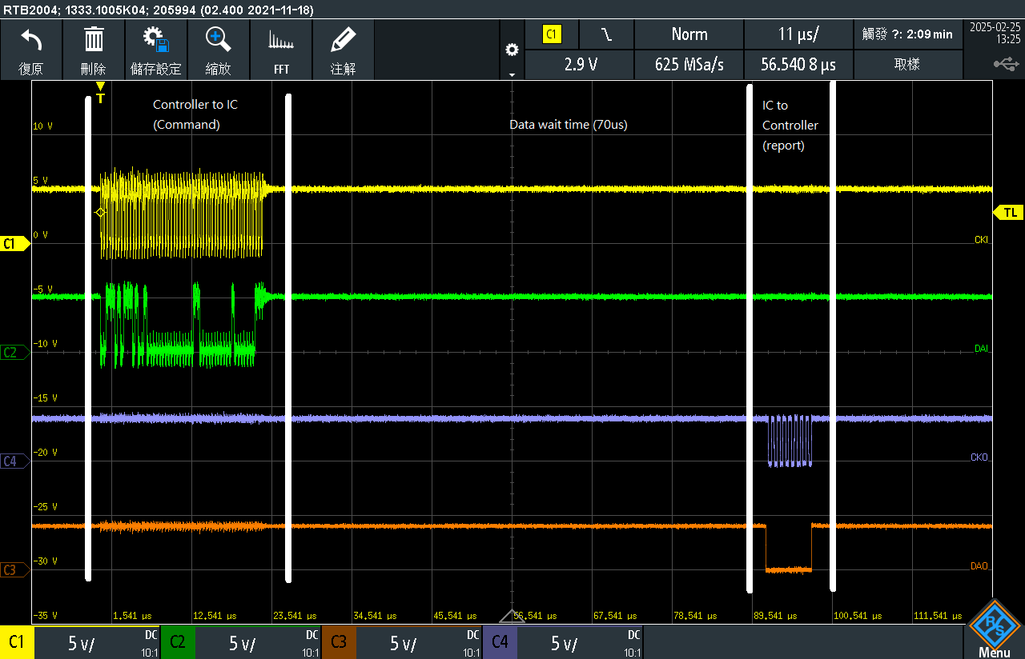

Fig. 7 Oscilloscope waveform of a GUI Temperature detect command

**PWM Command**

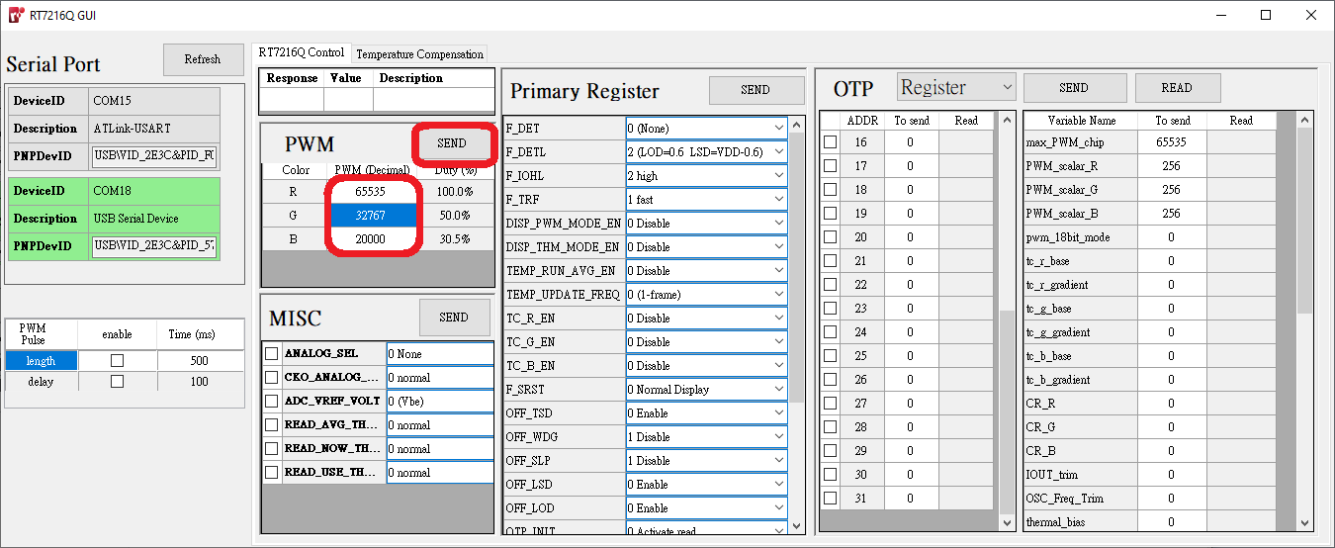

Fig. 8 PWM register

1. Set the PWM value between 0 and 65535. This controls the duty cycle for each output channel.   
   Note: The duty cycle % on the GUI is calculated only from pwm of output channel and (OTP register) max_PWM_chip.
2. Press Send to output a PWM command to the RT7216NQ IC.

Note: The final duty cycle should be incorporate PWM_scalar_R/G/B as well as tc_r/g/b_base and tc_r/g/b_gradient if temperature compensation is enabled. Refer to Programming Guide for details.

**Primary Register Command**

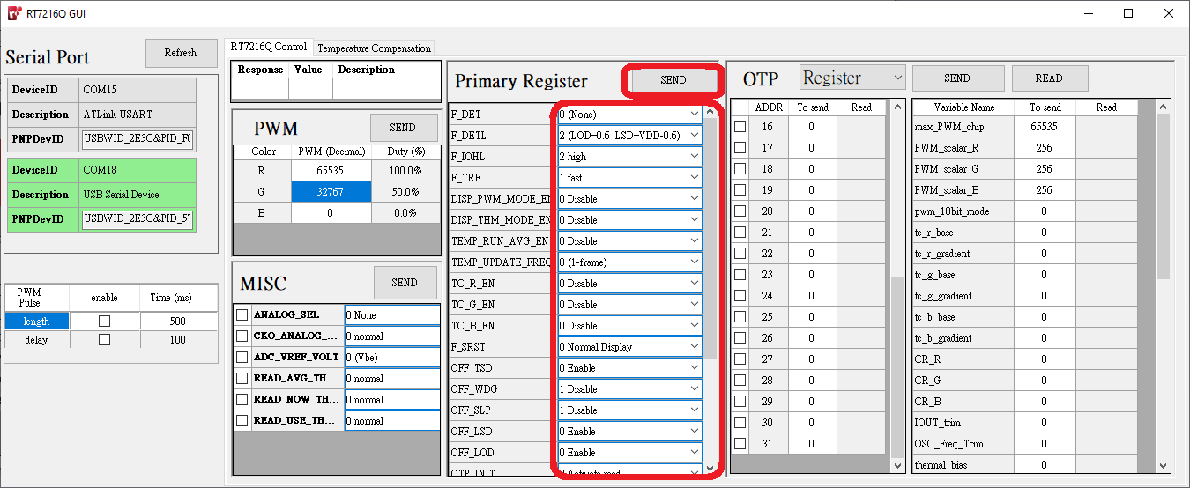

Fig. 9 Primary Register

Customize primary register settings, then configure the RT7216NQ IC by pressing send. The default settings on the GUI are for testing purposes. Refer to the Programming Guide for details function define.

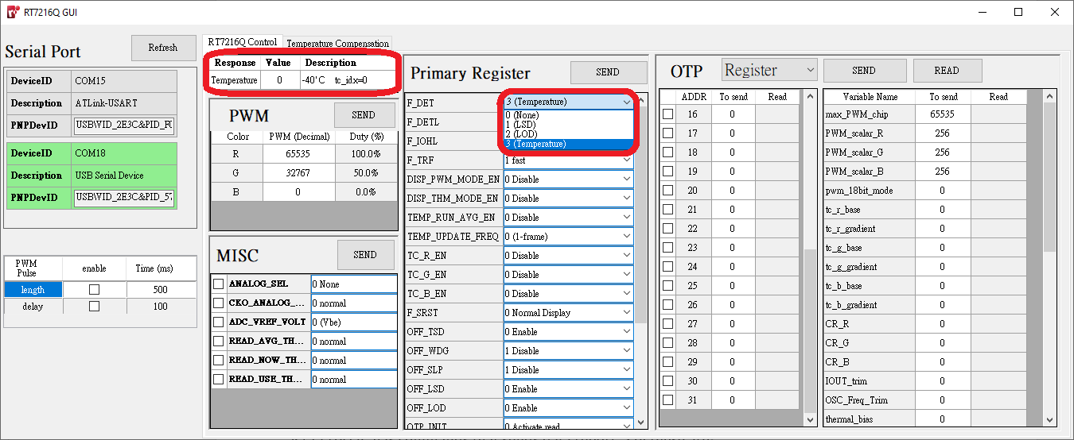

Fig. 10 Primary register data report

The LED Short Detection (LSD), LED Open Detection (LOD), and Temperature detection is selected by choosing F_DET in Primary Register. Data report will be displayed in the GUI.

Note: When the MCU fails to correctly detect data report, it may be due to noise. Try setting F_IOHL and READ_SPD to different levels and try again.

**Misc Register Command**

MISC register command is reserved for debugging purposes.

**OTP**

There are a total of 32 addresses for both OTP Register and OTP Memory. Each address stores an 8-bit value. OTP Register can by programmed many times. OTP Memory can only program each bit from 0 to 1 irreversibly. It is advised to test OTP functionality on OTP register first before permanently programming it in OTP Memory.

Choose the selected destination by selecting it in the outlined drop-down box.

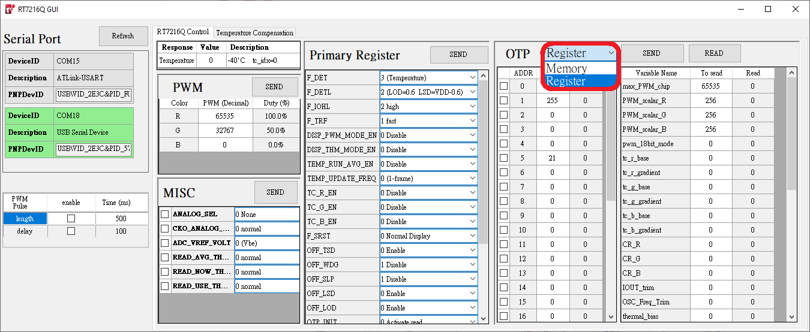

Fig. 11 OTP type select

The value in each OTP address (Red) is decoded and linked with its respective function variable (Blue).

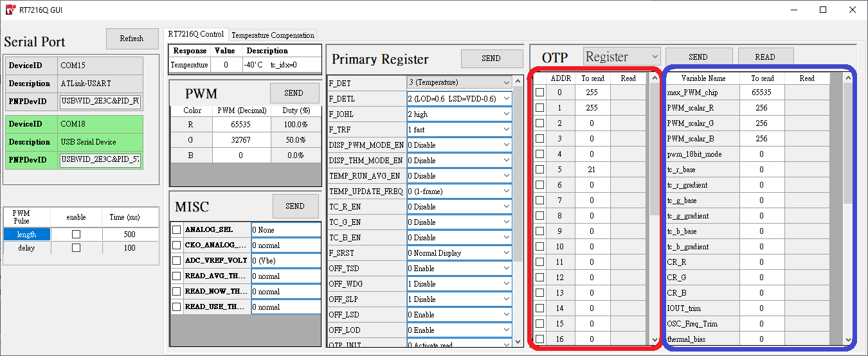

Fig. 12 OTP values and the decoded variable

The “Send” button will program the selected OTP addresses (outlines in blue). Beware that if Memory is selected, OTP memory will be programmed.

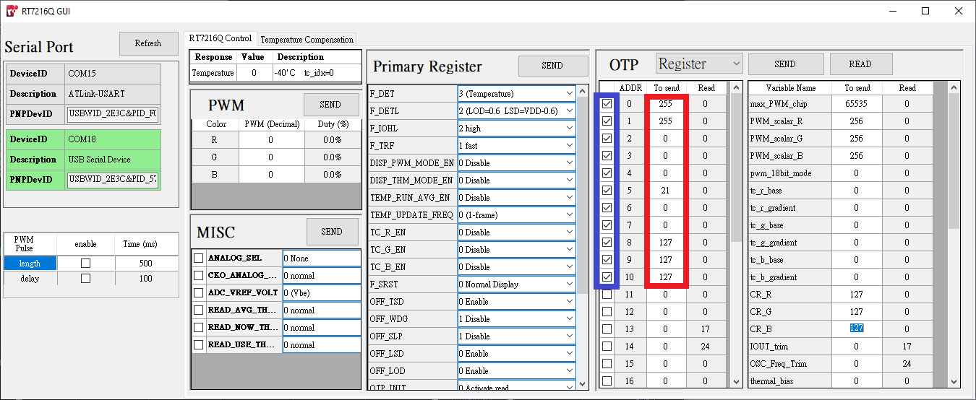

Fig. 13 OTP send selectively

The “READ” button reads all OTP address and displays them in the red outline. The OTP function variables is decoded and displayed in the blue outline.

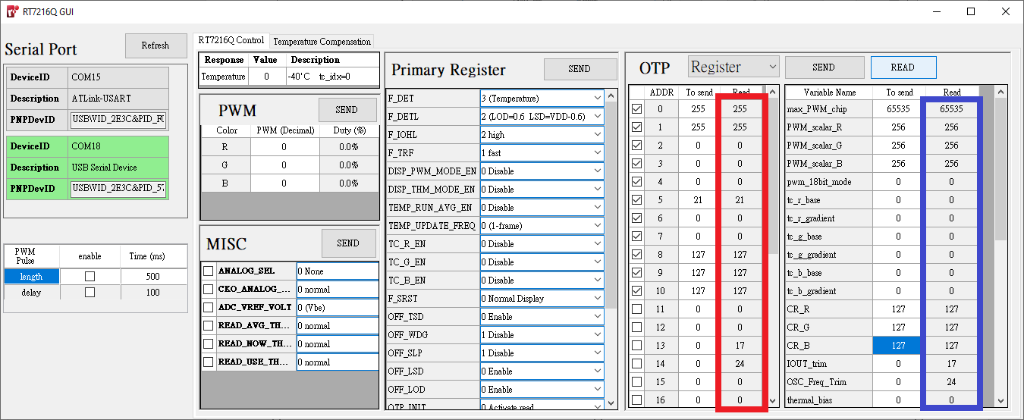

Fig. 14 OTP read all

**CIE 1931 chromaticity graph**

In the Temperature Compensation tab, CIE 1931 graph is magnified on the D65 chromaticity coordinate. Plot a test point on the graph by typing in the chromaticity coordinate.

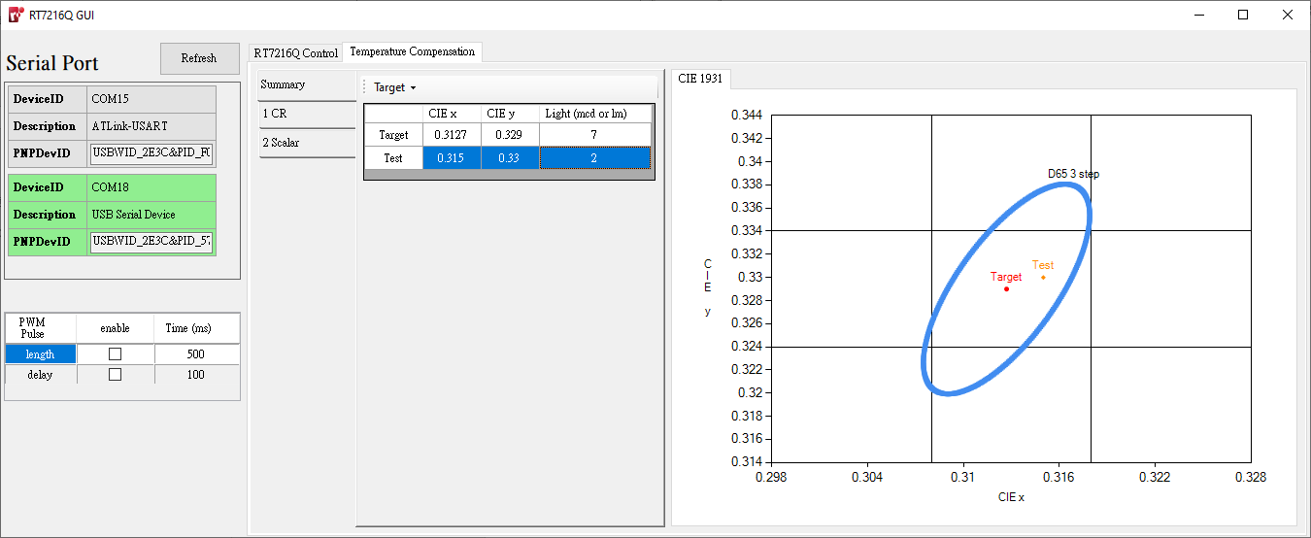

Fig. 15 Temperature Compensation page

**Temperature compensation - CR**

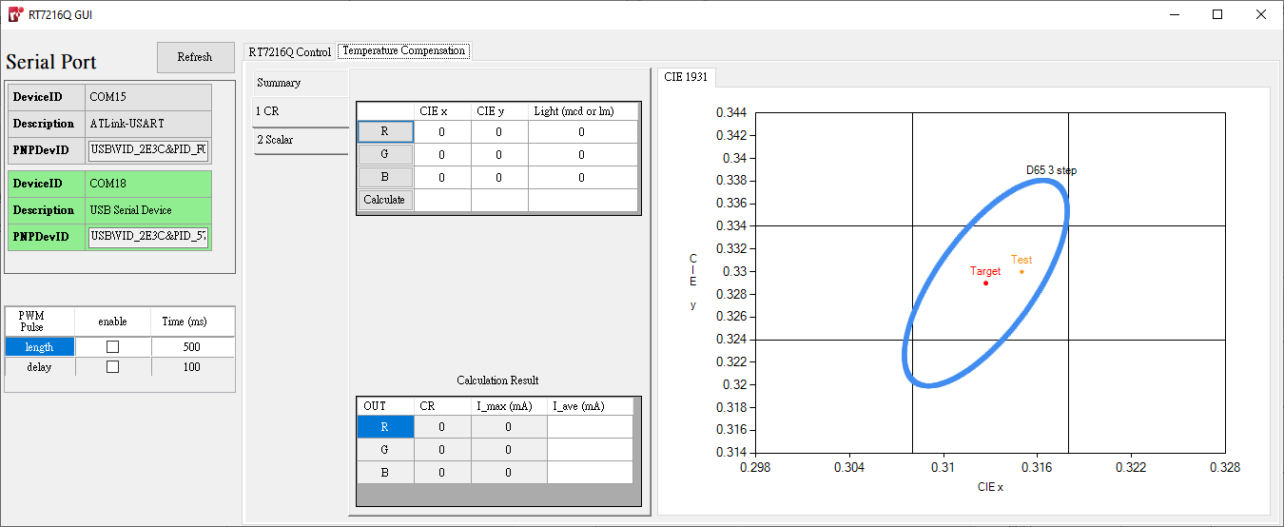

Fig. 16 Temperature Compensation CR

The CR tab under Temperature Compensation is used to find the current amplitude for D65. When buttons R/G/B is pressed, it will calibrate IC settings for measuring and calculating current ratio (CR) for the D65 chromaticity coordinate.

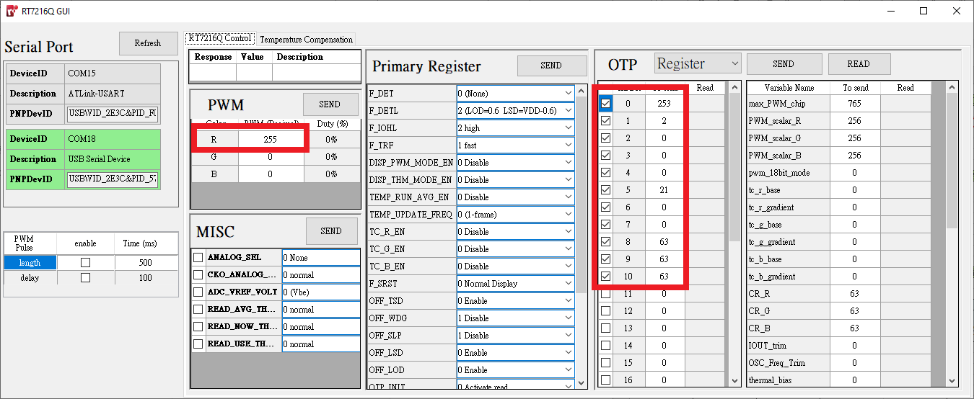

Fig. 17 IC settings for measuring CR after pressing “R”

To synchronize LED light up time with light spectrometer measure, use the PWM Pulse (outlined in red). If delay is enabled, MCU will be have a delay time before sending PWM command. If length is enabled, MCU will issue a PWM command to close LED outputs after the length of time entered.

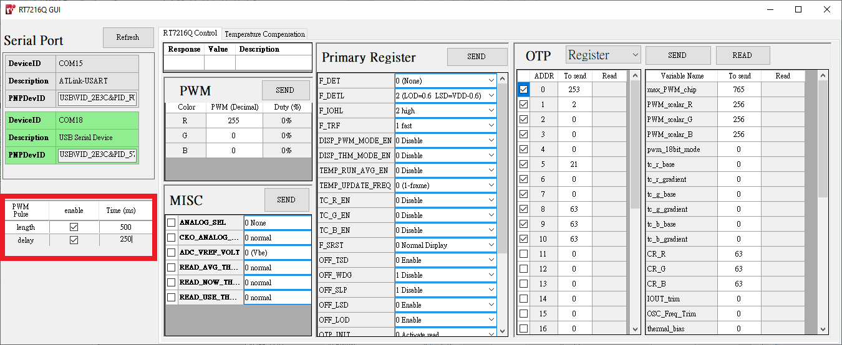

Fig. 18 Controller settings for synchronizing with light spectrometer

After the relevant measurements are made, enter the spectral data into the relevant fields, then press calculate. The calculated CR and estimated I_max, I_average be displayed.

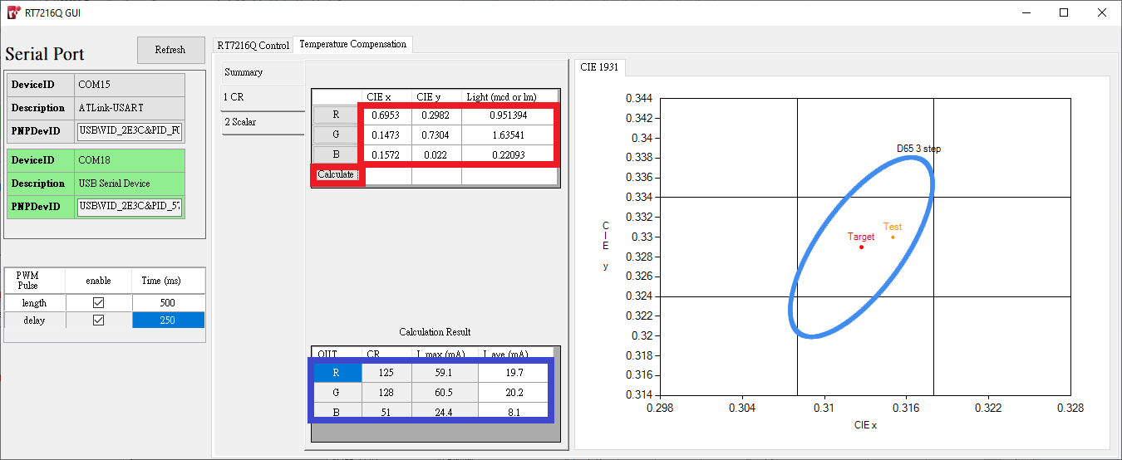

Fig. 19 CR calculation results

**Temperature compensation - Scalar**

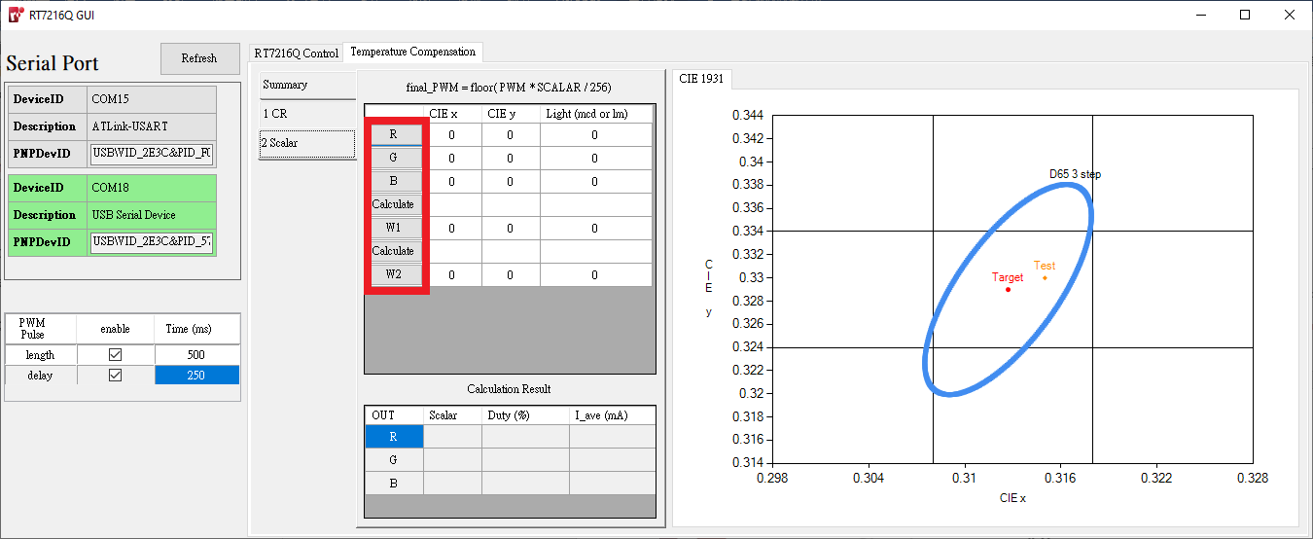

Fig. 20 Temperature Compensation Scalar

The Scalar tab under Temperature Compensation is used to measure and calculate the scaling required for each output for D65. When buttons R/G/B/W1/W2 is pressed, it will calibrate IC settings for measuring and calculating the PWM scalar for D65 chromaticity coordinate.

After pressing calculate, the PWM scalar values with be displayed below, along with the estimated duty cycle and I_average of each channel output.

Note: W2 is not used for calculation, it is only used to check whether the final chromaticity coordinate is within bounds.

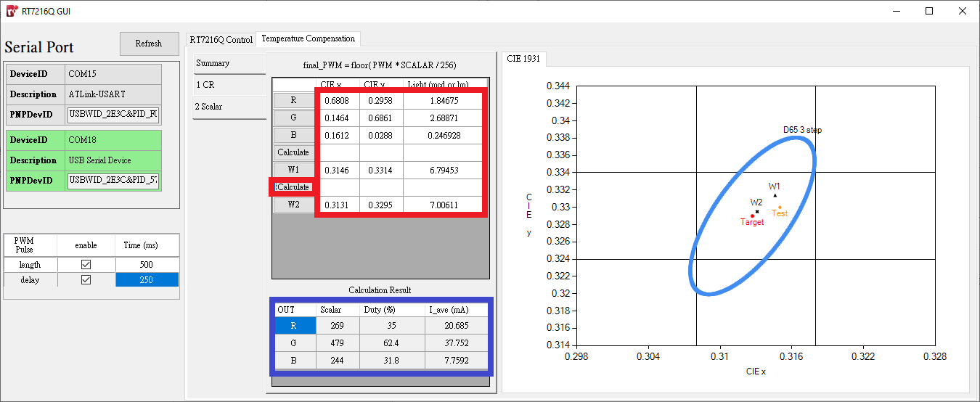

Fig. 21 Scalar calculation results

**Notice**

以上提供之所有內容，僅適用於銳發科技股份有限公司出產之指定產品，銳發科技股份有限公司保留權利得以隨時對此規格書或產品說明部分進行改版、補注、修訂，而不需另行通知。

所有銳發科技股份有限公司之產品，均未授權和設計使用於與軍事、航空、汽車、核能設備和維生系統相關之產品應用。客戶在銷售和使用上應用在以上設備或環境裡，須自行承擔風險，銳發科技股份有限公司沒有責任為任何問題負責。

The contents of this document are provided in connection with Raffar Technology Corporation products. Raffar reserve the right to make corrections, modifications, improvements, and other changes to the specifications and product descriptions at any time without notice.

Raffar products are not authorized, designed of intended for use in military/ aerospace/ automotive/ atomic energy control instruments applications or environment, or for other applications intended to support or sustains life. Raffar customer using and selling these products for use in such applications do so at their own risk. Raffar will not be responsible for any failure to meet such requirements.